CYB 300 Module Four Lab Worksheet One

Andree Salvo
Southern New Hampshire University
4-2 Lab Worksheet One: Certification Configuration and Management
Instructor: Jason Keltner

Lab: Certification Configuration and Management

Exercise 1: Enable Certificate-Based Authentication
Prompt | Response
Task 1: Take a screenshot of step 7 showing ssh active and running. Add your name in the command line. | 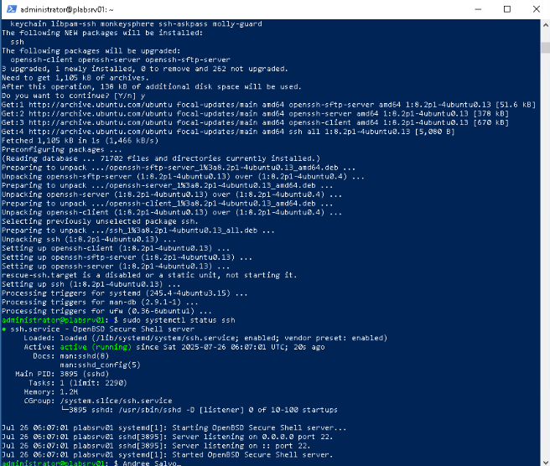

Exercise 2: Configure Server Keys SSH Certificates for Authentication
Prompt | Response
Task 2: Take a screenshot of Step 6 showing successful ssh update and new key installation. Add your name in the command line. | 